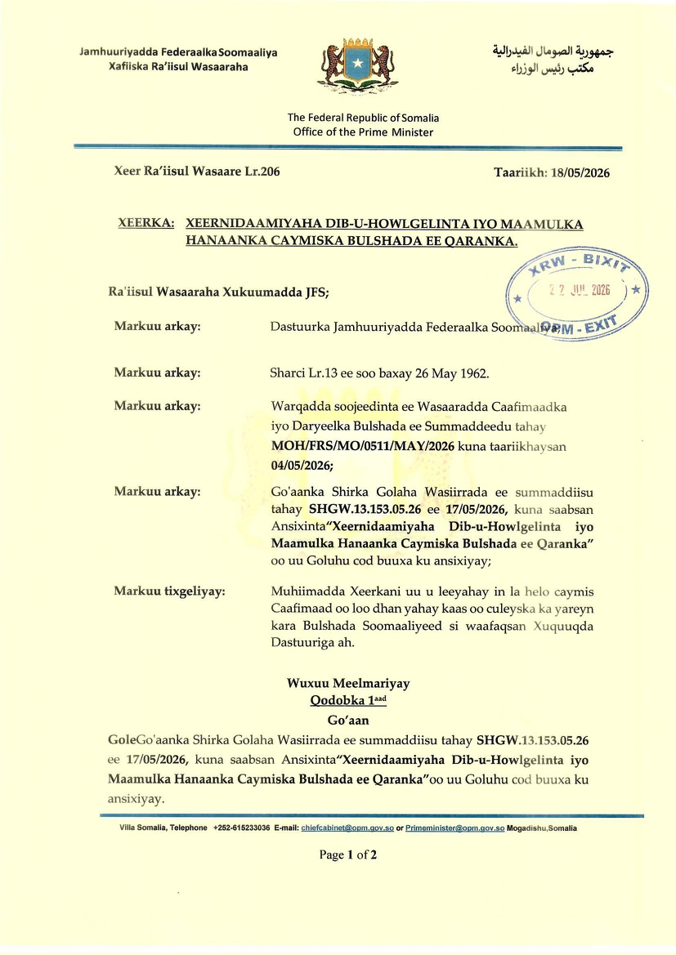

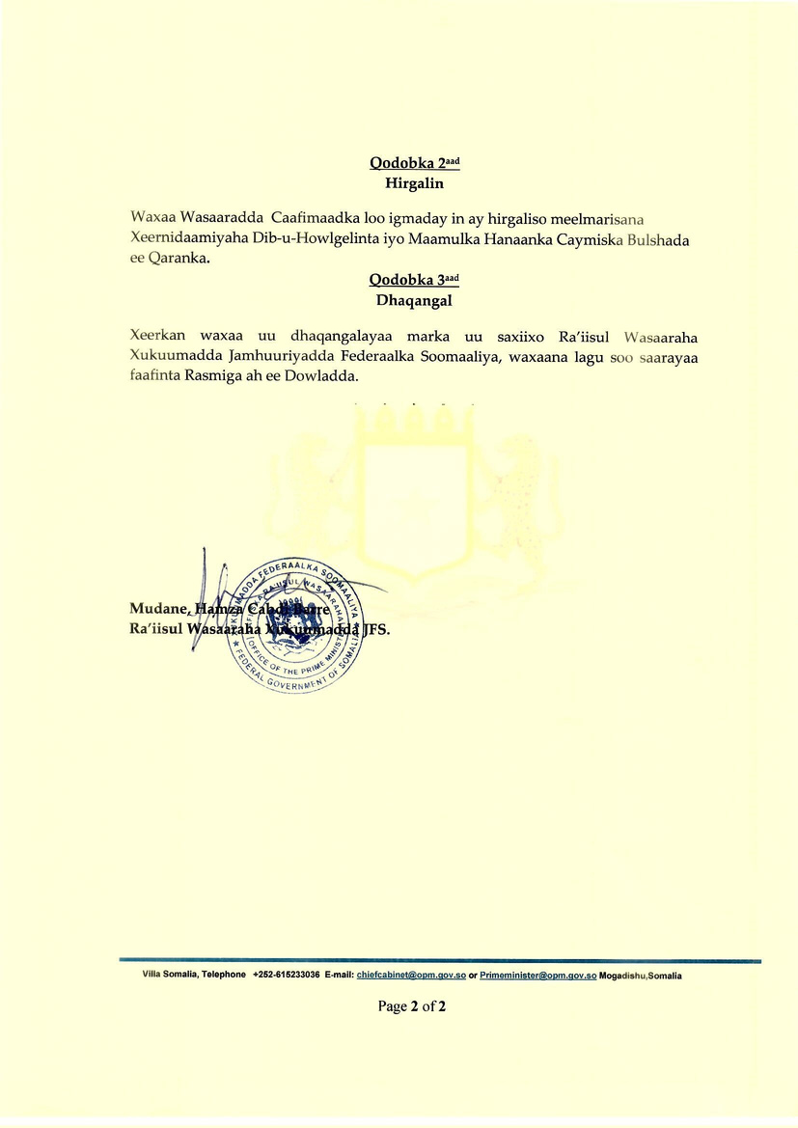

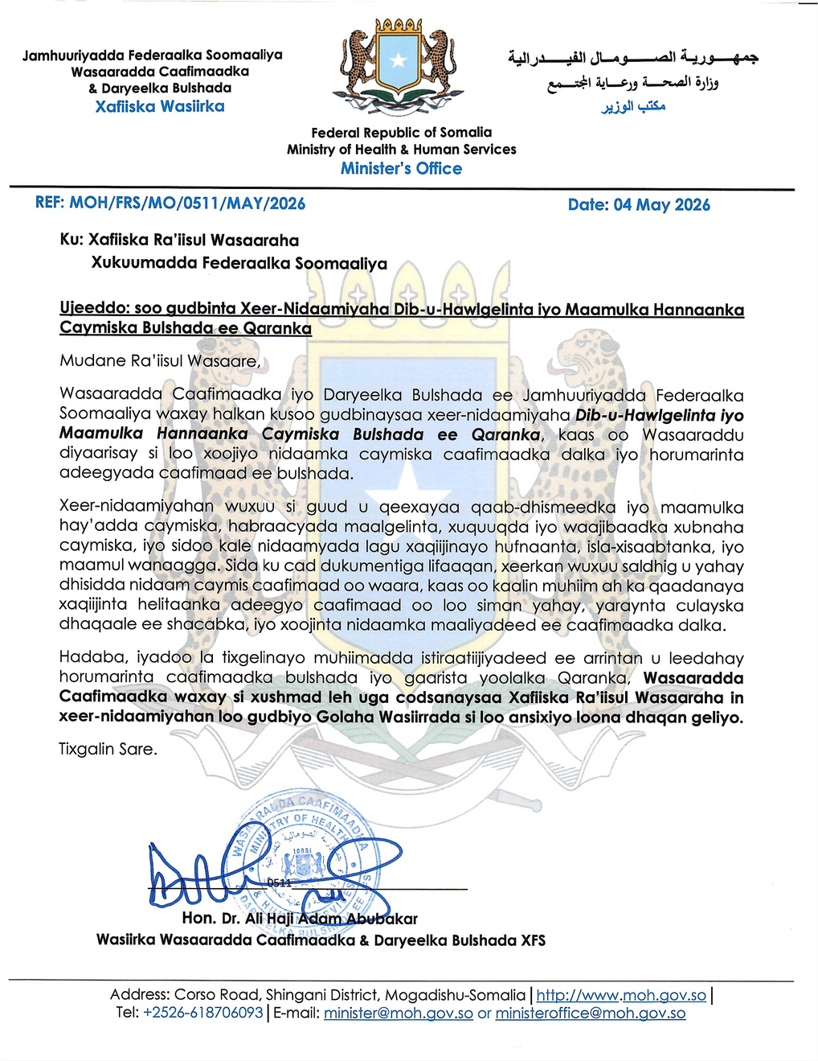

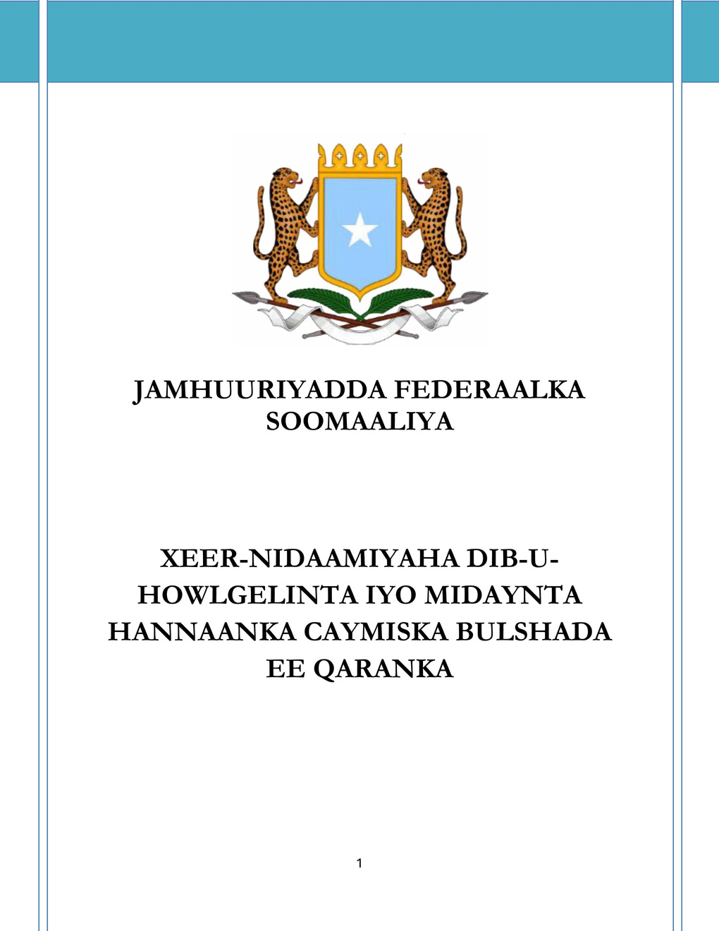

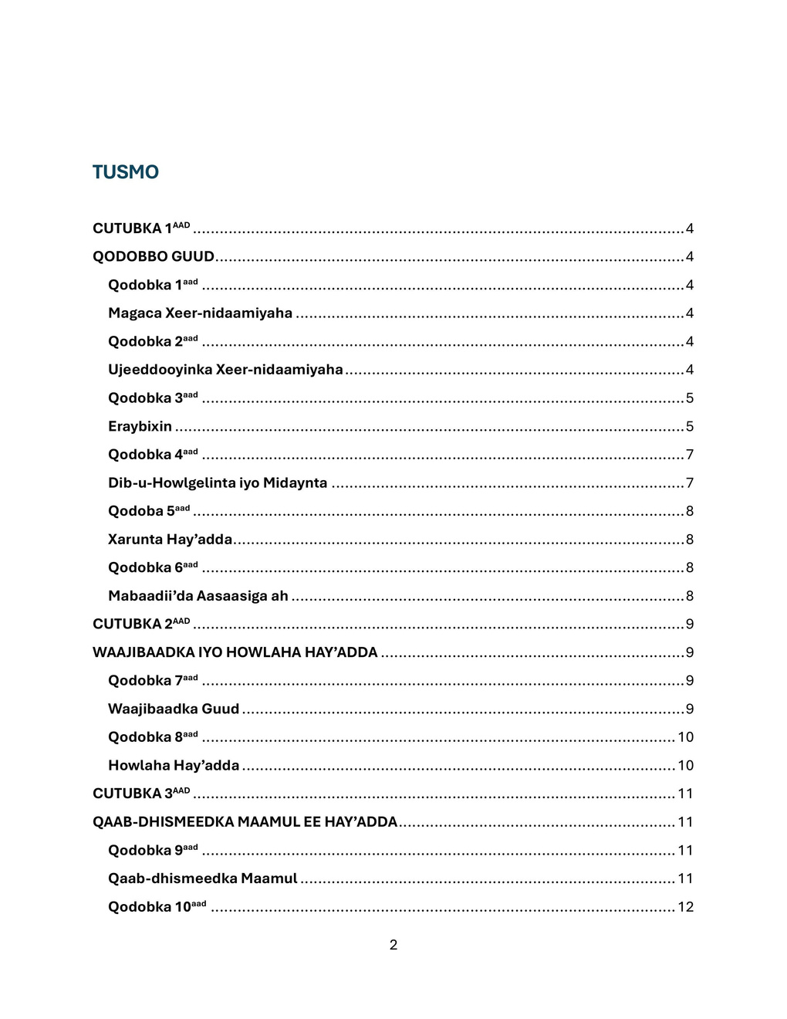

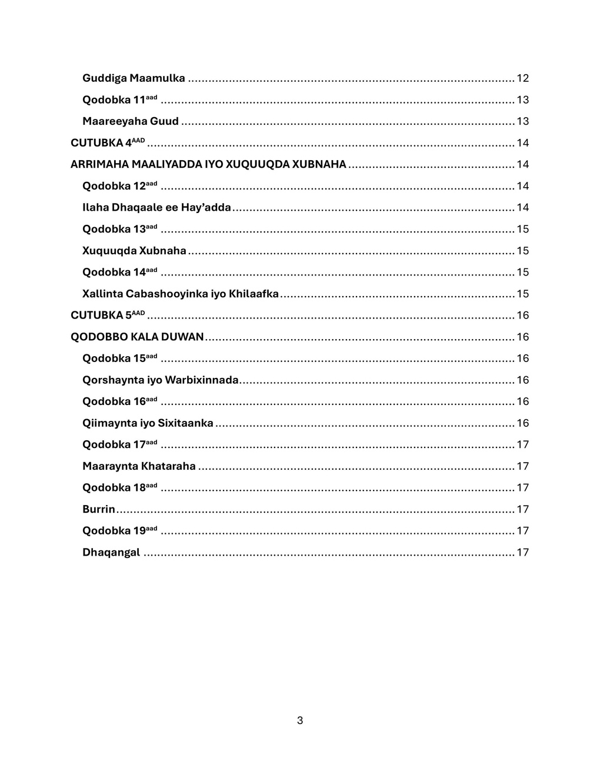

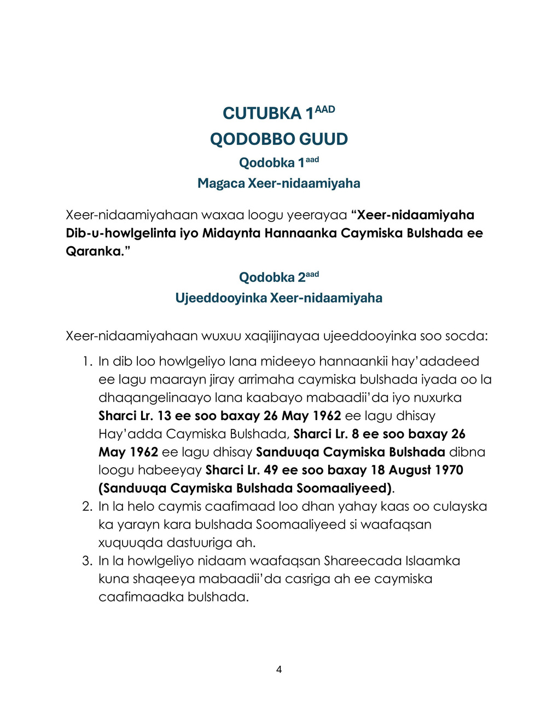

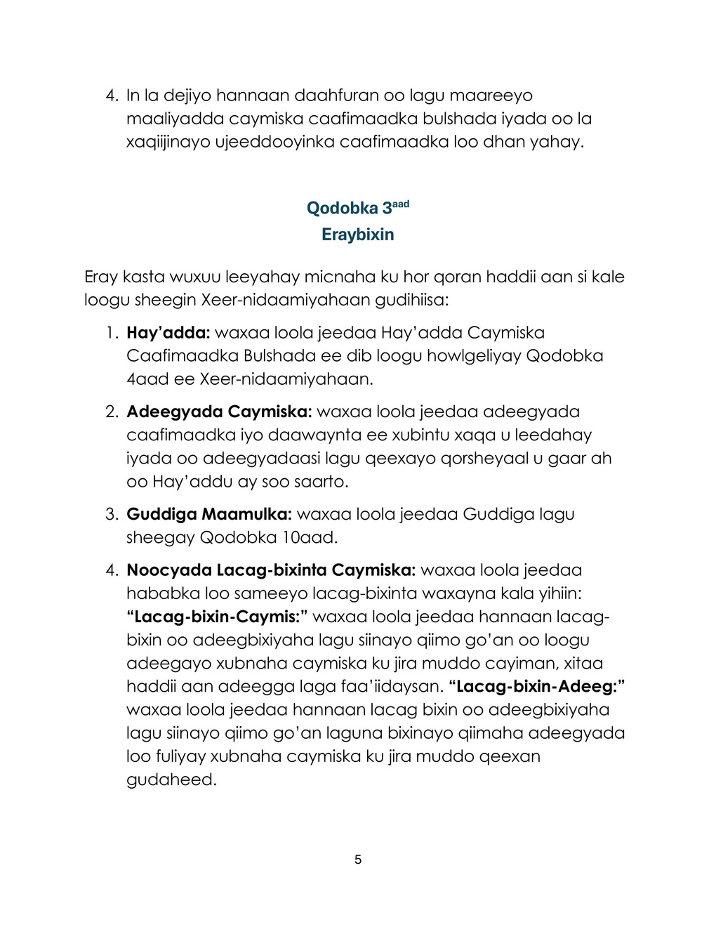

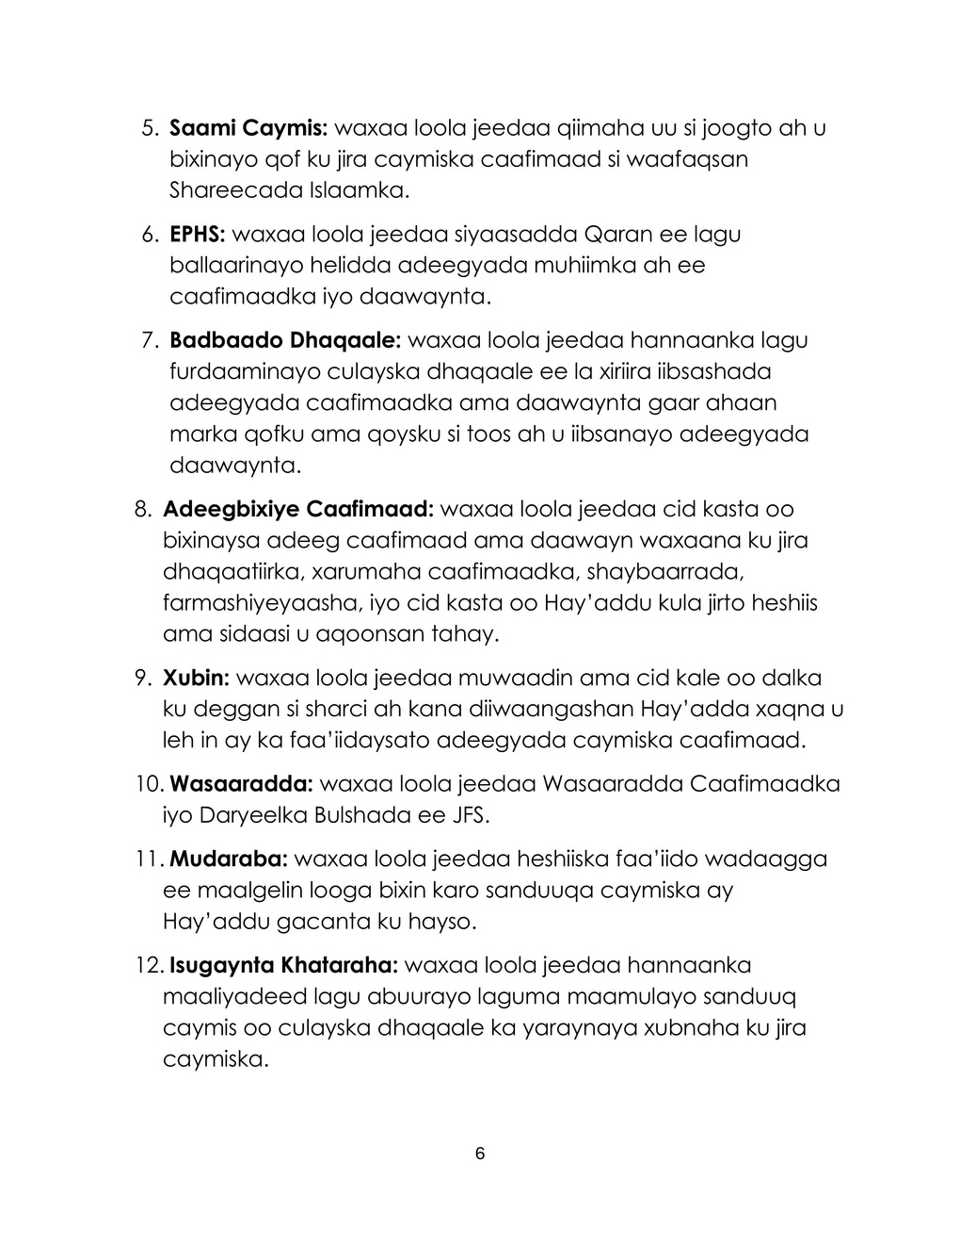

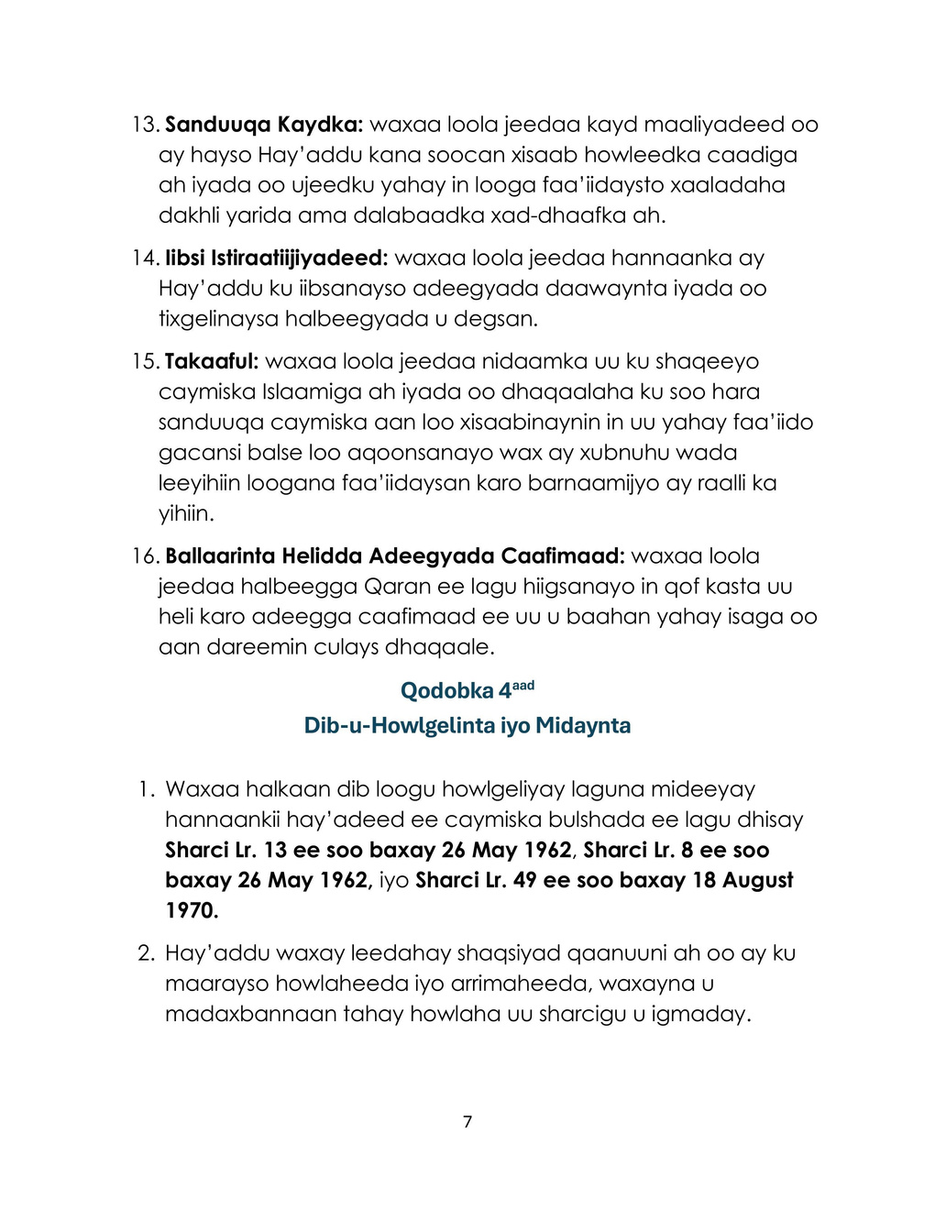

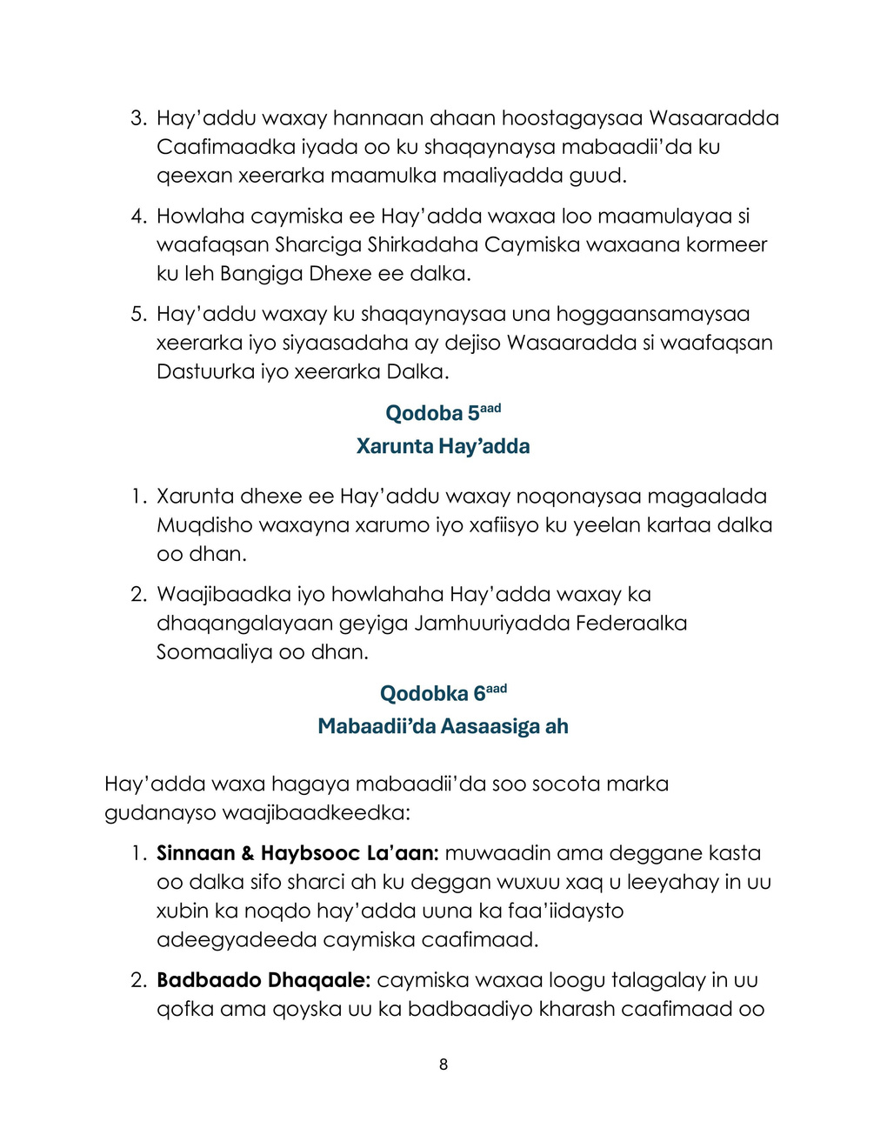

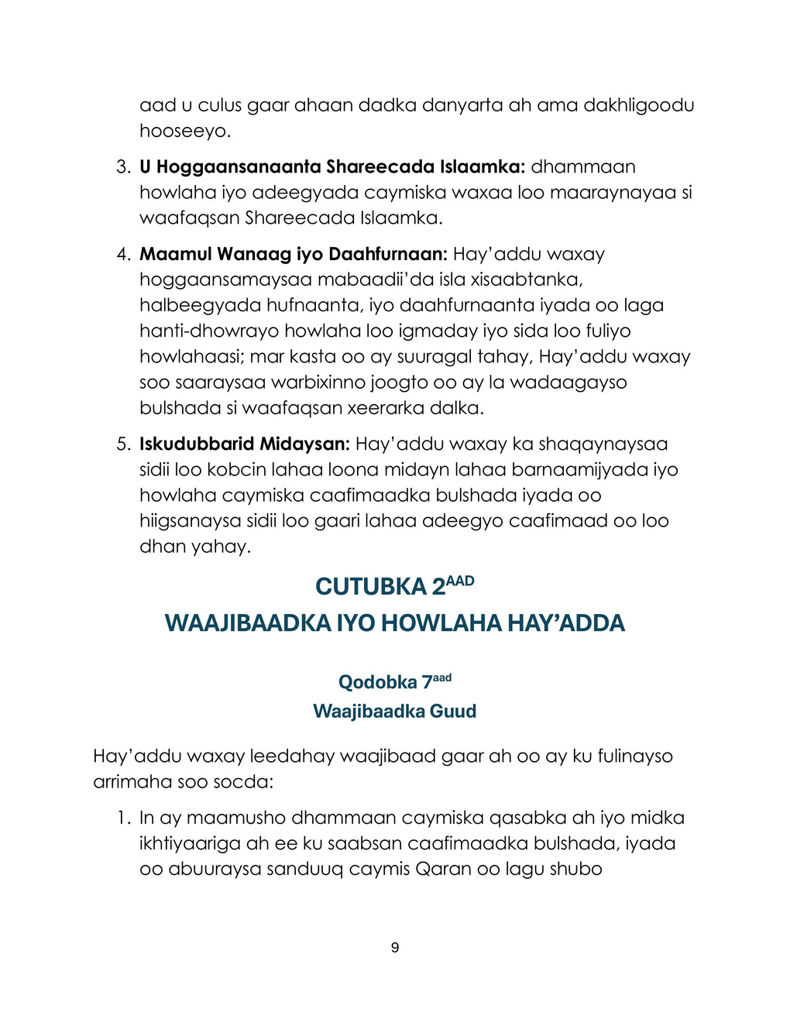

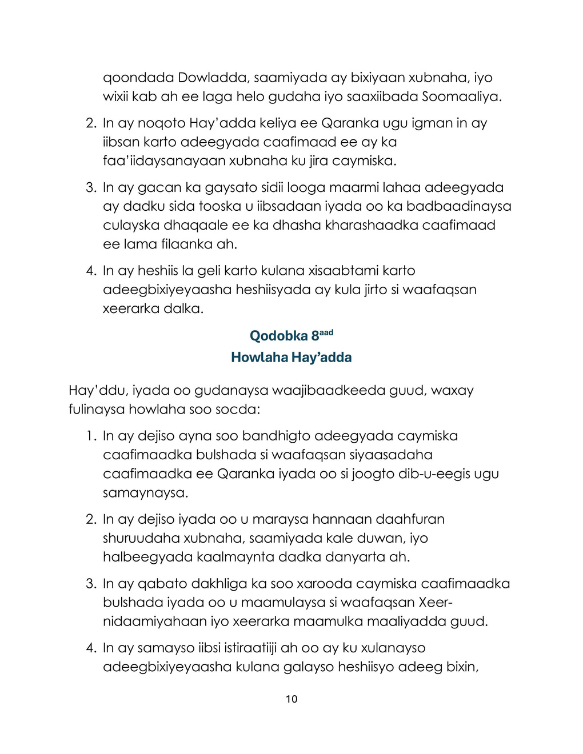

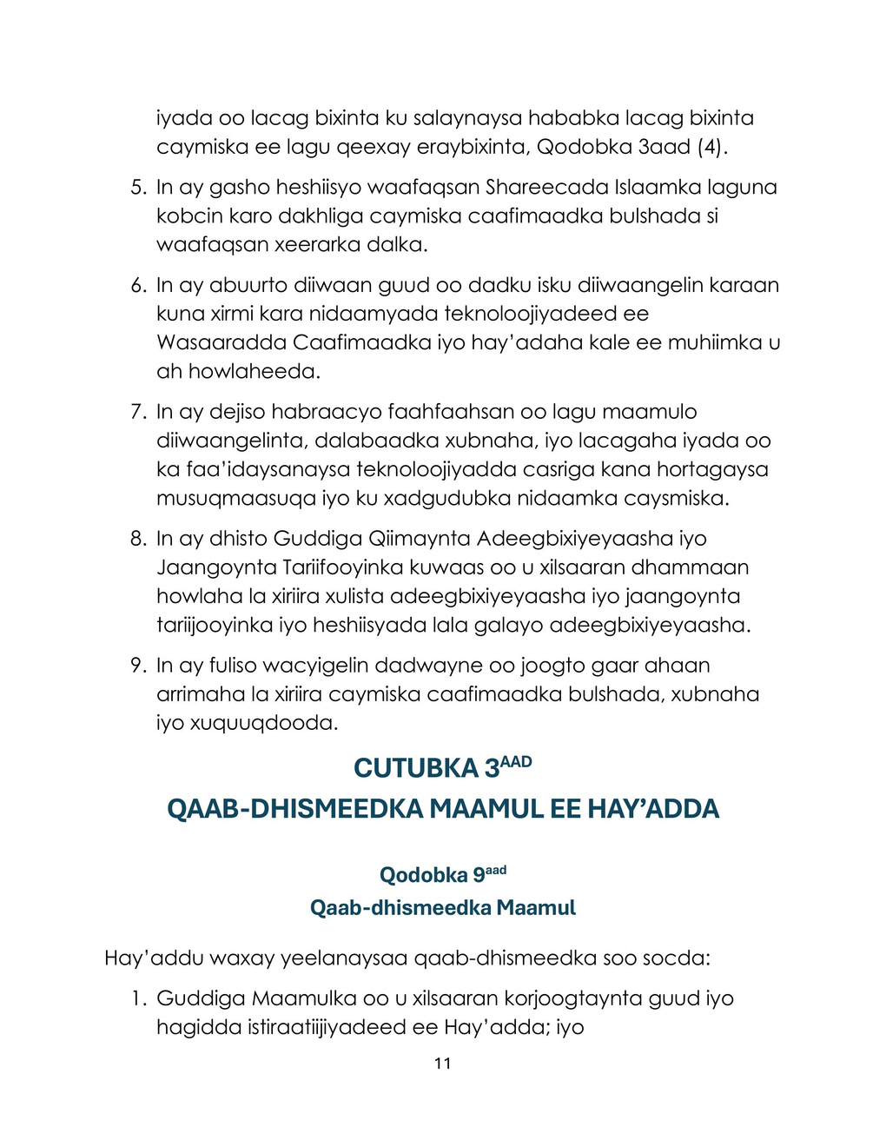

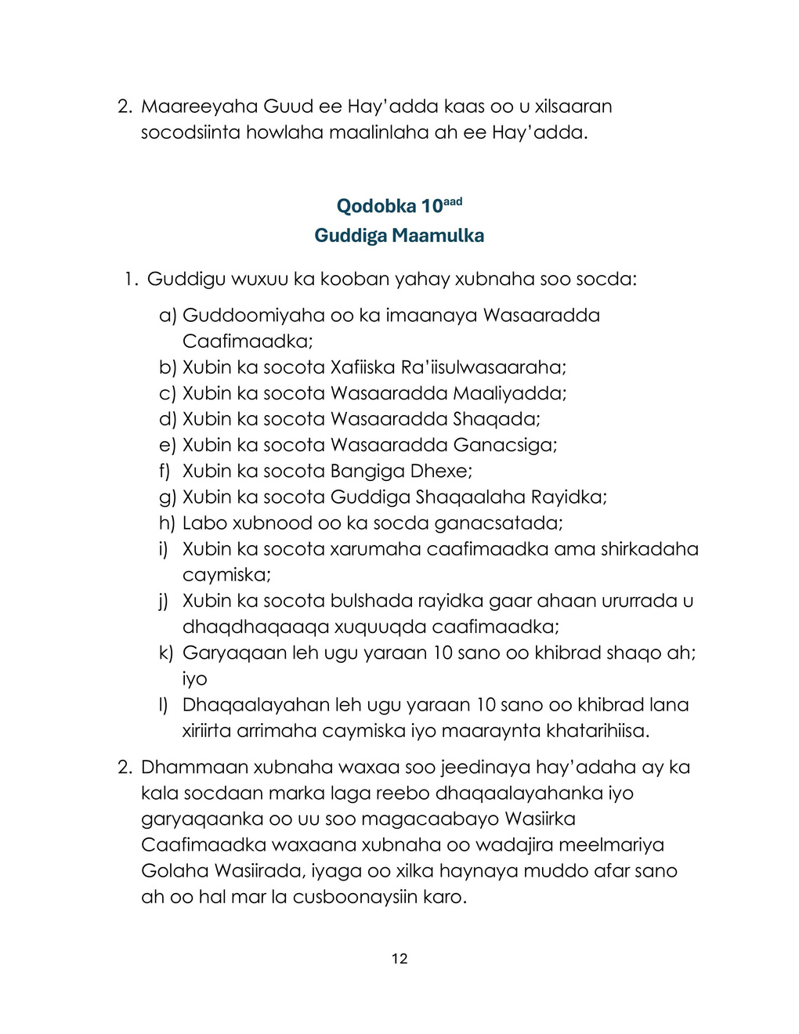

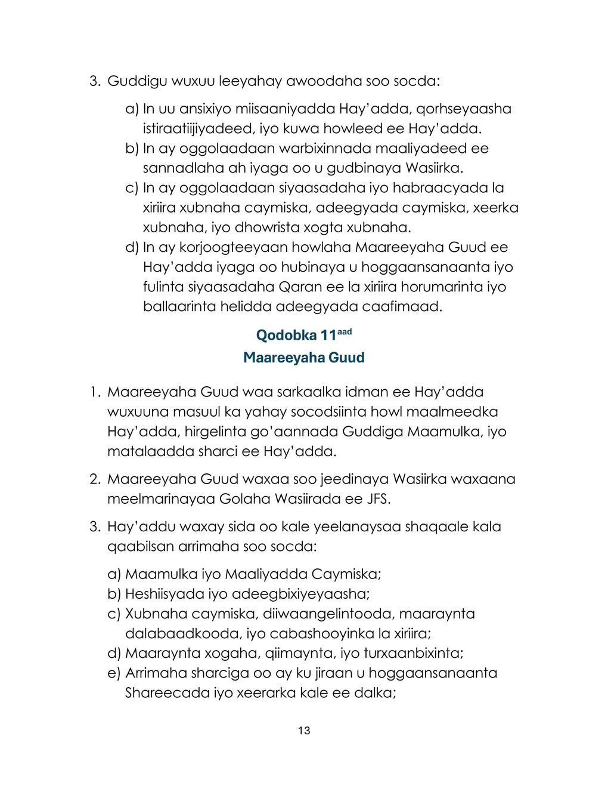

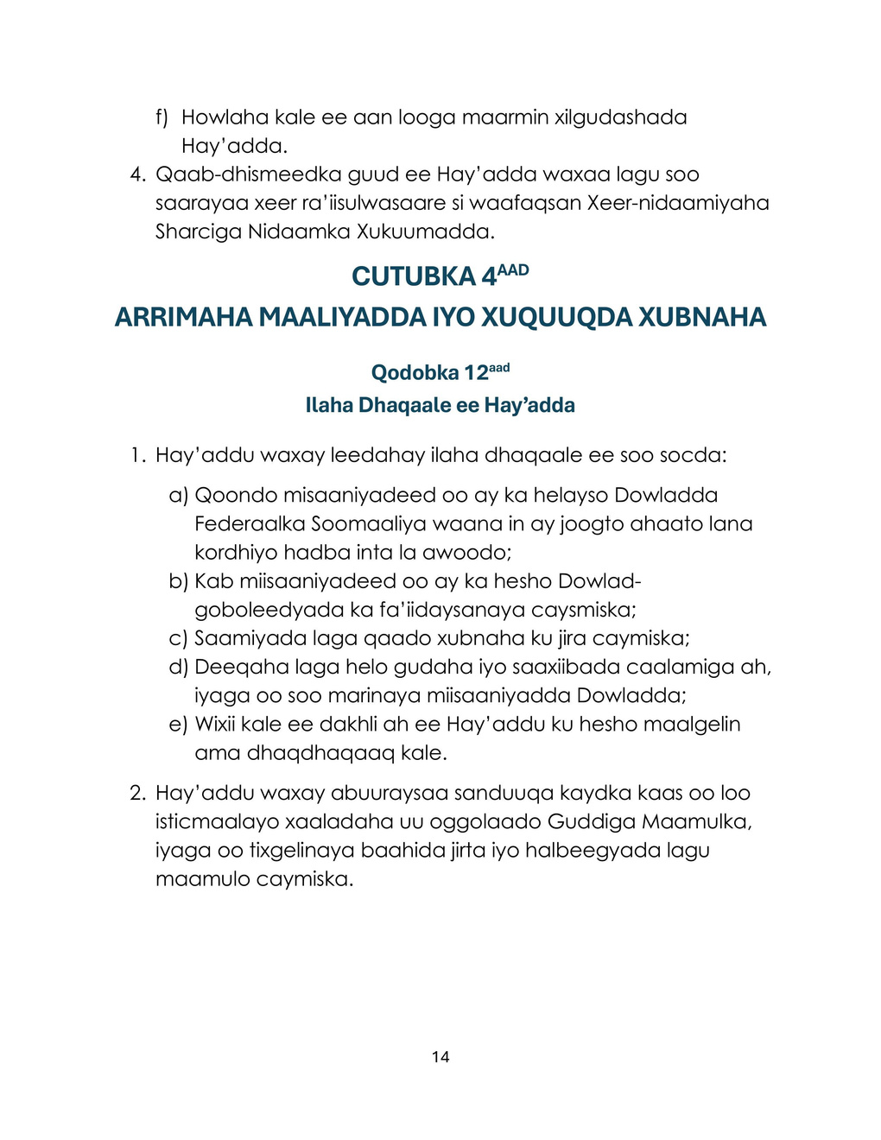

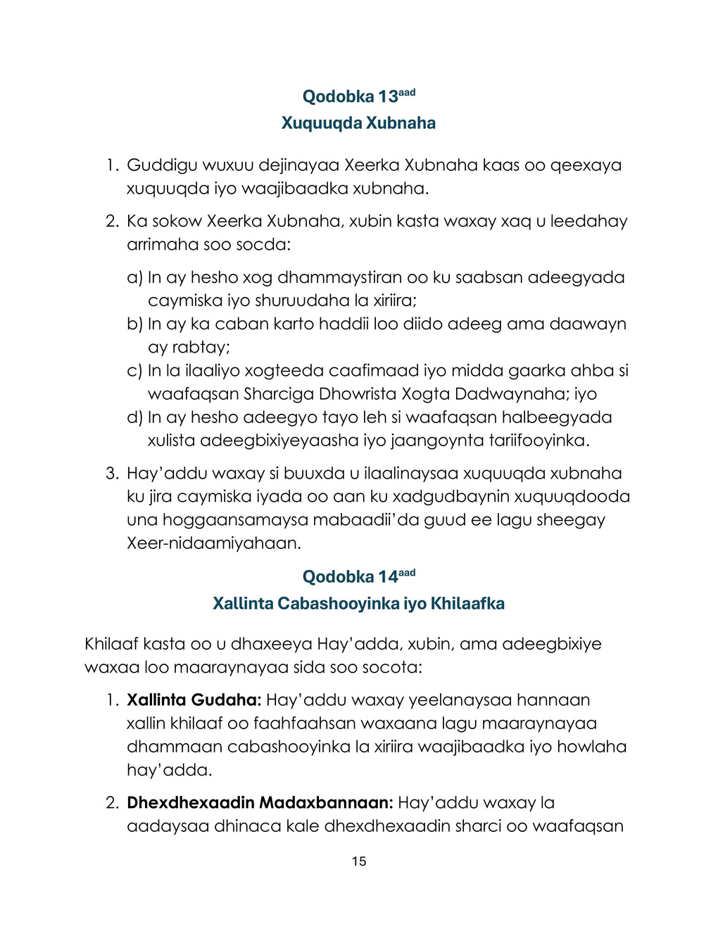

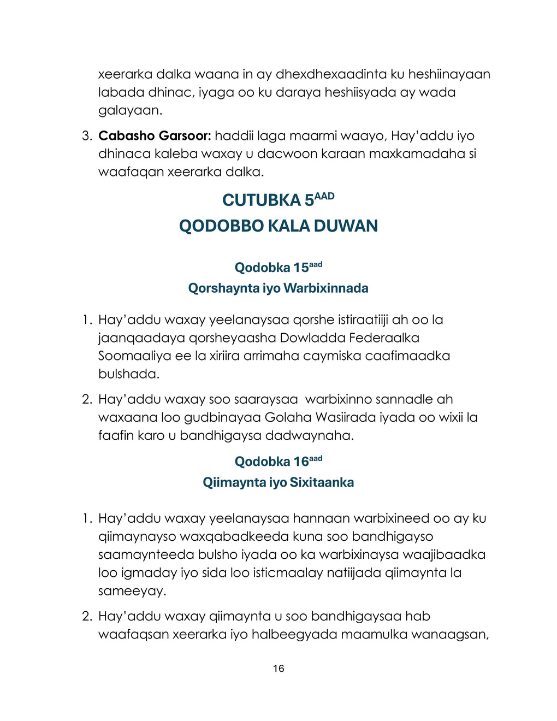

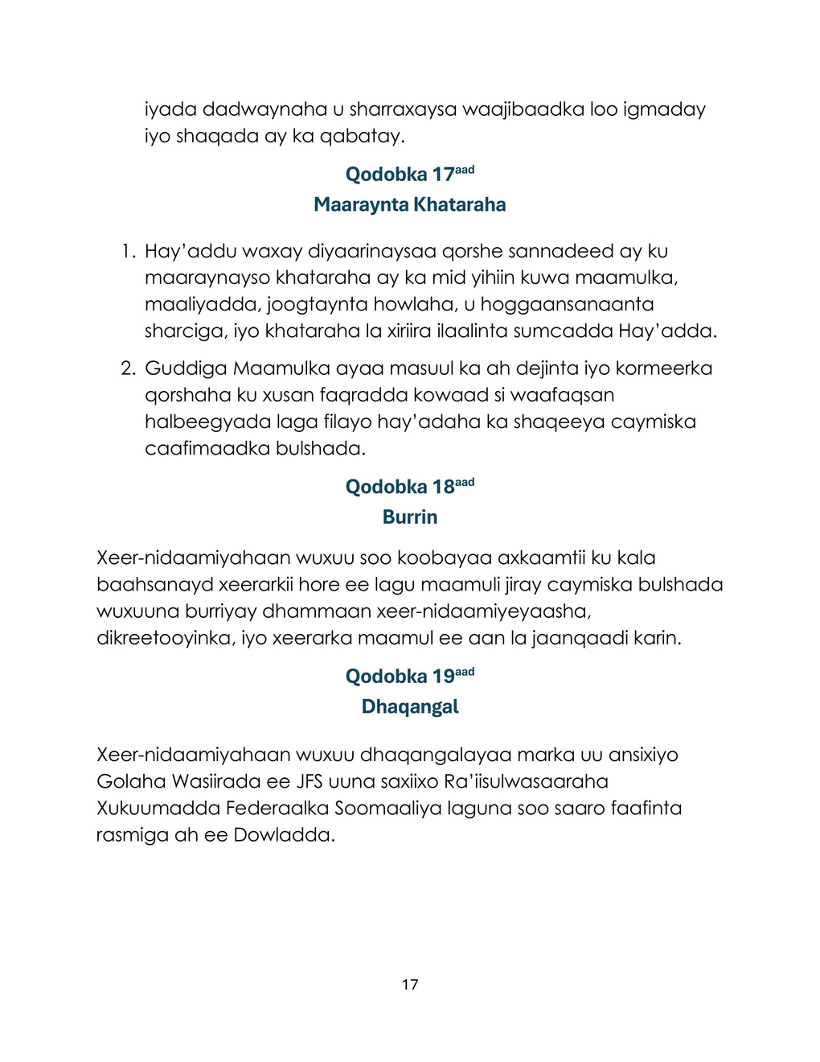

Prime Minister’s Decree No. 206
Date: 18/05/2026
DECREE: Regulations on the Re-Activation and Administration of the National Social Insurance System.

Office of the Prime Minister of the Government of the Federal Republic of Somalia (FRS)
XRWBIX
Prime Minister of the Government of the FRS: 22 JUL 2026

Having seen: The Constitution of the Federal Republic of Somalia.
Having seen: Law No. 13 issued on 26 May 1962.
Having seen: The proposal letter of the Ministry of Health and Social Care, referenced MOH/FRS/MO/0511/MAY/2026, dated 04/05/2026.
Having seen: The decision of the Council of Ministers’ meeting referenced SHGW.13.153.05.26 of 17/05/2026, concerning the approval of the “Regulations on the Re-Activation and Administration of the National Social Insurance System,” approved by the Council by unanimous vote.
Having considered: The importance of this Decree in achieving universal health insurance that can reduce the burden on the Somali people in accordance with constitutional rights.

Hereby approves the following:

Article 1
Decision
The decision of the Council of Ministers’ meeting referenced SHGW.13.153.05.26 of 17/05/2026, regarding the approval of the “Regulations on the Re-Activation and Administration of the National Social Insurance System,” approved by the Council by unanimous vote, is hereby endorsed.

Article 2
Implementation
The Ministry of Health is mandated to implement and enforce the Regulations on the Re-Activation and Administration of the National Social Insurance System.

Article 3
Entry into Force
This Decree shall enter into force upon signature by the Prime Minister of the Government of the Federal Republic of Somalia and shall be published in the Official Gazette of the Government.

H.E. Hamza Abdi Barre
Prime Minister of the Government of the FRS

Cover Letter
REF: MOH/FRS/MO/0511/MAY/2026
Date: 04 May 2026
To: Office of the Prime Minister of the Federal Government of Somalia
Subject: Submission of the Regulations on the Re-Activation and Administration of the National Social Insurance System

Honourable Prime Minister,
The Ministry of Health and Social Care of the Federal Republic of Somalia hereby submits the Regulations on the Re-Activation and Administration of the National Social Insurance System, prepared by the Ministry to strengthen the national health insurance system and to enhance public health services.
These Regulations broadly define the institutional structure and governance of the insurance authority, financing procedures, the rights and obligations of insured members, and the systems for ensuring transparency, accountability, and good governance. As set out in the attached document, these Regulations constitute a foundation for establishing a sustainable health insurance system that will play a vital role in ensuring equitable access to health services, reducing the financial burden on citizens, and strengthening the country’s health financing system.
Therefore, considering the strategic importance of this matter for improving public health and achieving national goals, the Ministry of Health respectfully requests the Office of the Prime Minister to submit these Regulations to the Council of Ministers for approval and entry into force.

Respectfully,

Hon. Dr. Ali Haji Adam Abubakar
Minister, Ministry of Health & Social Care, FRS

FEDERAL REPUBLIC OF SOMALIA
REGULATIONS ON THE RE-ACTIVATION AND INTEGRATION OF THE NATIONAL SOCIAL INSURANCE SYSTEM

Table of Contents
Section | Page
CHAPTER 1 — General Provisions | 4
Article 1 — Name of the Regulations | 4
Article 2 — Objectives of the Regulations | 4
Article 3 — Definitions | 5
Article 4 — Re-Activation and Integration | 7
Article 5 — Headquarters of the Authority | 8
Article 6 — Fundamental Principles | 8
CHAPTER 2 — Duties and Functions of the Authority | 9
Article 7 — General Duties | 9
Article 8 — Functions of the Authority | 10
CHAPTER 3 — Administrative Structure of the Authority | 11
Article 9 — Administrative Structure | 11
Article 10 — Board of Directors | 12
Article 11 — Director General | 13
CHAPTER 4 — Financial Matters and Members’ Rights | 14
Article 12 — Sources of the Authority’s Funds | 14
Article 13 — Members’ Rights | 15
Article 14 — Resolution of Complaints and Disputes | 15
CHAPTER 5 — Miscellaneous Provisions | 16
Article 15 — Planning and Reports | 16
Article 16 — Evaluation and Correction | 16
Article 17 — Risk Management | 17
Article 18 — Repeal | 17
Article 19 — Entry into Force | 17

CHAPTER 1 — GENERAL PROVISIONS

Article 1
Name of the Regulations
These Regulations shall be called: “Regulations on the Re-Activation and Integration of the National Social Insurance System.”

Article 2
Objectives of the Regulations
These Regulations shall ensure the following objectives:
To re-activate and integrate the institutional system through which social insurance matters were previously administered, by implementing and strengthening the principles and substance of Law No. 13 issued on 26 May 1962 establishing the Social Insurance Authority; Law No. 8 issued on 26 May 1962 establishing the Social Insurance Fund, as restructured by Law No. 49 issued on 18 August 1970 (Somali Social Insurance Fund).
To achieve universal health insurance that can reduce the burden on the Somali people in accordance with constitutional rights.
To operationalize a system compliant with Islamic Sharia and functioning according to modern principles of public health insurance.
To establish a transparent system for managing public health insurance finances while ensuring the objectives of universal health coverage.

Article 3
Definitions
Each term shall have the meaning set out below unless otherwise stated within these Regulations:
“Authority” means the Public Health Social Insurance Authority re-activated under Article 4 of these Regulations.
“Insurance Services” means the health and treatment services to which a member is entitled, as defined in specific plans issued by the Authority.
“Board of Directors” means the Board referred to in Article 10.
“Types of Insurance Payment” means the methods of payment, including:
“Capitation Payment” means a payment method whereby the provider is paid a fixed amount to serve insured members for a specified period, even if services are not utilized; and
“Fee-for-Service Payment” means a payment method whereby the provider is paid a fixed price based on the value of services delivered to insured members within a specified period.
“Insurance Contribution” means the amount paid regularly by a person enrolled in health insurance in accordance with Islamic Sharia.
“EpHS” means the national policy for expanding access to essential health and treatment services.
“Financial Protection” means the mechanism for alleviating the financial burden related to purchasing health or treatment services, especially when an individual or household purchases treatment directly.
“Health Care Provider” means any entity providing health services or treatment, including physicians, health facilities, laboratories, pharmacies, and any entity contracted with or recognized by the Authority.
“Member” means a citizen or any other person legally residing in the country who is registered with the Authority and entitled to benefit from health insurance services.
“Ministry” means the Ministry of Health and Social Care of the FRS.
“Mudaraba” means a profit-sharing investment agreement through which the insurance fund managed by the Authority may be invested.
“Risk Pooling” means a financial mechanism for creating and managing an insurance fund that reduces the financial burden on insured members.
“Reserve Fund” means a financial reserve held by the Authority, separate from ordinary operational accounts, intended for use in situations of low revenue or excessive claims.
“Strategic Purchasing” means the mechanism by which the Authority purchases treatment services while considering its established standards.
“Takaful” means the Islamic insurance model under which any surplus remaining in the insurance fund is not treated as an individual profit, but is recognized as collectively owned by members and may be used for programs acceptable to them.
“Expanding Access to Health Services” means the national benchmark aimed at ensuring that every person can obtain the health care they need without suffering financial hardship.

Article 4
Re-Activation and Integration
The institutional social insurance system established under Law No. 13 issued on 26 May 1962, Law No. 8 issued on 26 May 1962, and Law No. 49 issued on 18 August 1970 is hereby re-activated and integrated.
The Authority shall have legal personality through which it manages its activities and affairs, and it shall be independent in the functions assigned to it by law.
As an institutional arrangement, the Authority shall fall under the Ministry of Health and shall operate in accordance with the principles set out in the public financial administration rules.
The Authority’s insurance operations shall be administered in accordance with the Insurance Companies Law and shall be supervised by the Central Bank of the country.
The Authority shall operate and comply with the regulations and policies issued by the Ministry in accordance with the Constitution and the laws of the country.

Article 5
Headquarters of the Authority
The Authority’s headquarters shall be in Mogadishu, and it may establish branches and offices throughout the country.
The duties and functions of the Authority shall apply throughout the territory of the Federal Republic of Somalia.

Article 6
Fundamental Principles
In carrying out its duties, the Authority shall be guided by the following principles:
Equality & Non-Discrimination: Every citizen or resident legally residing in the country has the right to become a member of the Authority and to benefit from its health insurance services.
Financial Protection: Insurance is intended to protect individuals and households from very high health costs, especially the poor and low-income groups.
Compliance with Islamic Sharia: All insurance activities and services shall be managed in accordance with Islamic Sharia.
Good Governance and Transparency: The Authority shall adhere to accountability principles, efficiency standards, and transparency, and its mandated activities and performance shall be subject to audit; whenever possible, the Authority shall publish regular reports and share them with the public in accordance with the laws of the country.
Integrated Coordination: The Authority shall work to strengthen and integrate programs and activities of public health insurance with the aim of achieving universal health coverage.

CHAPTER 2 — DUTIES AND FUNCTIONS OF THE AUTHORITY

Article 7
General Duties
The Authority shall have specific duties in carrying out the following matters:
To manage all mandatory and voluntary social health insurance by establishing a National Insurance Fund into which shall be deposited the Government’s allocations, members’ contributions, and any other support obtained domestically and from Somalia’s partners.
To be the sole national authority mandated to purchase health services to be utilized by insured members.
To contribute to reducing reliance on direct out-of-pocket payments by protecting people from the financial burden arising from unexpected health expenditures.
To enter into contracts with, and hold accountable, contracted health care providers in accordance with the laws of the country.

Article 8
Functions of the Authority
In fulfilling its general duties, the Authority shall perform the following functions:
To design and make available public health insurance services in accordance with national health policies, and to review them regularly.
To establish, through a transparent process, membership requirements, different contribution levels, and standards for subsidizing vulnerable groups.
To collect and manage revenues generated from public health insurance in accordance with these Regulations and public financial management rules.
To conduct strategic purchasing by selecting providers and entering into service-delivery contracts, using the insurance payment methods defined in Article 3(4).
To enter into Sharia-compliant agreements that can increase public health insurance revenues in accordance with the laws of the country.
To establish a general registry through which people can enroll and that can be linked to the Ministry of Health’s technology systems and other institutions essential to its work.
To establish detailed procedures for managing registration, member claims, and payments by leveraging modern technology and preventing corruption and abuse of the insurance system.
To establish the Provider Assessment and Tariff Standardization Committee, responsible for all functions related to provider selection and the standardization of tariffs and contracts with providers.
To carry out continuous public awareness initiatives, especially on matters relating to public health insurance, members, and their rights.

CHAPTER 3 — ADMINISTRATIVE STRUCTURE OF THE AUTHORITY

Article 9
Administrative Structure
The Authority shall have the following structure:
A Board of Directors responsible for overall oversight and strategic guidance of the Authority; and
A Director General of the Authority responsible for managing the day-to-day operations of the Authority.

Article 10
Board of Directors
The Board shall consist of the following members:
Chairperson from the Ministry of Health.
A member from the Office of the Prime Minister.
A member from the Ministry of Finance.
A member from the Ministry of Labour.
A member from the Ministry of Commerce.
A member from the Central Bank.
A member from the Civil Service Commission.
Two members representing the business community.
A member representing health facilities or insurance companies.
A member representing civil society, especially organizations advocating for health rights.
A lawyer with at least ten (10) years of professional experience.
An economist with at least ten (10) years of experience related to insurance matters and risk management.
The members shall be nominated by their respective institutions, except for the economist and the lawyer who shall be appointed by the Minister of Health. The members collectively shall be endorsed by the Council of Ministers, and they shall serve a term of four (4) years, renewable once.
The Board shall have the following powers:
To approve the Authority’s budget, strategic plans, and operational plans.
To approve annual financial reports and submit them to the Minister.
To approve policies and procedures related to insured members, insurance services, the membership regulation, and the protection of members’ data.
To oversee the work of the Director General and ensure compliance with, and implementation of, national policies related to improving and expanding access to health services.

Article 11
Director General
The Director General is the authorized executive officer of the Authority and shall be responsible for the daily management of the Authority, implementation of decisions of the Board of Directors, and the legal representation of the Authority.
The Director General shall be nominated by the Minister and approved by the Council of Ministers of the FRS.
The Authority shall also have staff responsible for the following areas:
Administration and insurance finance.
Contracts and provider relations.
Insured members, registration, claims management, and related complaints.
Data management, evaluation, and verification.
Legal affairs, including compliance with Islamic Sharia and other national laws.
Other functions essential to the fulfillment of the Authority’s mandate.
The Authority’s overall organizational structure shall be issued through a Prime Ministerial decree in accordance with the Regulation of the Government’s Legal System (Xeer-nidaamiyaha Sharciga Nidaamka Xukuumadda).

CHAPTER 4 — FINANCIAL MATTERS AND MEMBERS’ RIGHTS

Article 12
Sources of the Authority’s Funds
The Authority shall have the following sources of funds:
A budget allocation from the Federal Government of Somalia, which shall be maintained and increased whenever possible.
A budgetary contribution from Federal Member States benefiting from the insurance.
Contributions collected from insured members.
Grants received domestically and from international partners through the Government budget.
Any other income obtained by the Authority through investment or other activities.
The Authority shall establish a Reserve Fund to be used in situations approved by the Board of Directors, taking into account existing needs and standards for managing insurance.

Article 13
Members’ Rights
The Board shall issue a Membership Regulation defining the rights and obligations of members.
In addition to the Membership Regulation, each member shall have the right to:
Receive complete information on insurance services and related conditions.
Submit a complaint if a service or treatment they sought is denied.
Have their medical and personal data protected in accordance with the Public Data Protection Law.
Receive quality services in accordance with provider selection standards and tariff standardization procedures.
The Authority shall fully protect the rights of insured members without violating their rights and shall comply with the general principles stated in these Regulations.

Article 14
Resolution of Complaints and Disputes
Any dispute between the Authority, a member, or a provider shall be managed as follows:
Internal Resolution: The Authority shall establish a detailed internal dispute-resolution mechanism and shall manage all complaints related to the Authority’s duties and functions through it.
Independent Mediation: The Authority shall pursue legal mediation with the other party in accordance with national law; the parties shall agree to the mediation and incorporate relevant terms into the contracts they enter into.
Judicial Complaint: Where resolution is not possible, the Authority and/or the other party may bring a claim before the courts in accordance with national law.

CHAPTER 5 — MISCELLANEOUS PROVISIONS

Article 15
Planning and Reports
The Authority shall prepare a strategic plan aligned with the Federal Government of Somalia’s plans related to public health insurance matters.
The Authority shall produce annual reports and submit them to the Council of Ministers, and shall publish what may be publicly disclosed for the benefit of the public.

Article 16
Evaluation and Correction
The Authority shall establish a reporting mechanism to evaluate its performance and present its social impact, reporting on its assigned duties and the use of evaluation results.
The Authority shall present evaluations in a manner consistent with rules and standards of good governance, explaining to the public its mandated duties and the work performed.

Article 17
Risk Management
The Authority shall prepare an annual plan to manage risks, including administrative risks, financial risks, continuity risks, legal compliance risks, and risks related to safeguarding the Authority’s reputation.
The Board of Directors shall be responsible for developing and overseeing the plan referred to in paragraph one (1), in accordance with standards expected of institutions working in public health insurance.

Article 18
Repeal
These Regulations consolidate provisions that were previously dispersed across earlier instruments governing social insurance and hereby repeal all regulations, decrees, and administrative rules that are inconsistent with these Regulations.

Article 19
Entry into Force
These Regulations shall enter into force upon approval by the Council of Ministers of the FRS and signature by the Prime Minister of the Federal Government of Somalia, and upon publication in the Official Gazette of the Government.

